

Darshan University

A Project Report on

“Car Service Management System ”

Under the subject

Software Engineering (2301CS405)

B. Tech, Semester – IV

Computer Science & Engineering Department

Submitted By
Student Name: Rutvik Makvana | Enrollment No.: 24010101160
Academic Year
(2025-2026)
Internal Guide  Prof. R. B. Gondaliya  Darshan University | Dean-DIET  Dr. Gopi Sanghani  Darshan University

 | Computer Science & Engineering Department  Darshan University

DECLARATION

We hereby declare that the SRS, submitted along with the Software Engineering (2301CS405) for entitled “Car service Management System” submitted in partial fulfilment for the Semester-5 of Bachelor Technology (B. Tech) in Computer Science and Engineering (CSE) Department to Darshan University, Rajkot, is a record of the work carried out at Darshan University, Rajkot under the supervision of R. B. Gondaliya and that no part of any of report has been directly copied from any students’ reports, without providing due reference.

Rutvik Makvana

Student’s Signature

Date: __________

 | Computer Science & Engineering Department  Darshan University

CERTIFICATE

This is to certify that the SRS on “Car Service Management System” has been satisfactorily prepared by Rutvik Makvana (24010101160) under my guidance in the fulfillment of the course Software Engineering (2301CS405) work during the academic year 2025-202.

Internal Guide  Prof. R. B. Gondaliya  Darshan University |  | Dean-DIET  Dr. Gopi Sanghani  Darshan University

Acknowledgement
I wish to express my sincere gratitude to my project guide Prof. R. B. Gondaliya and all the faculty members for helping me through my project by giving me the necessary suggestions and advices along with their valuable co- ordination in completing this work.

I also thank my parents, friends and all the members of the family for their precious support and encouragement which they had provided in completion of my work. In addition to that, I would also like to mention the Darshan University personals who gave me the permission to use and experience the valuable resources required for the project from the University premises.

Thus, in conclusion to the above said, I once again thank the faculties and members of Darshan University for their valuable support in completion of the project.

Thanking You
Rutvik Makvana

ABSTRACT
Car service management system is a system which aims in developing a computerized system to maintain all the daily operation of car service. This system will act as a tool to transfer traditional manual service process into digital system. This project has many features which are generally not available in manual service centers, like service-booking, real-time service updates etc. It also has a facility of manager login through which the manager can monitor the whole system. This system will be designed with the basic features such as manager can add/view/update/delete service details and worker's details in it. It has also a facility for customer to after logging in their accounts can see register vehicle detail and booked service appointment and view service cost and track service status. Worker can log in to view assigned jobs, update job status, and add service notes. The manager, after logging into the manager account, can assign the job to worker, view inventory, generate bills and invoices, and produce various reports such as service reports, customer reports, worker’s performance reports, and billing reports.

Main purpose of this system is to reduce human efforts as much as possible and to improve efficiency, accuracy, and service quality in car service center management.

Table of Contents
List of Figures I
List of Tables II
1 Introduction 1
1.1 Product perspective 1
1.2 Product features 1
1.2.1 There are three different users who will be using this product: 1
1.2.2 The features that are required for the Manager are: 1
1.2.3 The features that are required for the Member are: 1
1.3 Functional Requirement 1
1.3.1 Manger 1
1.3.2 Worker 2
• Authentication: Worker must log in to access the system. 2
• View Assigned Jobs: View list of service jobs assigned by the manager. 2
• View Vehicle Details: Access vehicle and service details for assigned jobs. 2
• Update Job Status: Update service status (started, in-progress, completed). 2
• Add Service Notes: Add remarks or observations during servicing. 2
• Request Spare Parts: Request required spare parts during servicing. 2
• Report Additional Issues: Notify manager about additional repairs needed. 2
• Service Completion: Mark service job as completed after finishing work. 2
1.3.3 Customer 2
• Authentication: Customer must be authenticated before accessing the system. 2
• Search Service: Search available service types. 2
• Request Service: Book a service appointment after selecting service type. 2
• Add Vehicle Details: Add and manage personal vehicle information. 2
• Track Service Status: View real-time service progress. 2
• View Service History: Access previous service records. 2
• Check Account: View account details, bills, and invoices. 2
• Provide Feedback: Submit feedback after service completion. 2
1.4 Non-Functional Requirement 2
1.4.1 Usability: 2
1.4.2 Accuracy: 2
1.4.3 Availability: 2
1.4.4 Maintainability: 2
2 Design and Implementation Constraints 3
2.1 Use case diagram 3
2.2 Activity diagram and Swimlane diagram 4
2.3 Sequence diagram 5
2.4 State diagram 5
2.5 Class diagram 7
2.6 Data flow diagram 8
2.6.1 Context diagram (level-0) 8
2.6.2 DFD Level-1 8
3 External interface requirement (Screens) 9
3.1 Screen-1: Registration Form 9
3.2 Screen-2: Login Form 10
3.3 Screen-3: Book Car Service 11
3.4 Screen-4: Tracking Service Status 12
3.5 Screen-4: Car Health Analysis 13
4 Database design 13
4.1 List of Tables 13
5 Stories and Scenario 15
5.1 Story-1: Add New Car in car service 15
5.1.1 Scenario# S1.1 15
5.1.2 Scenario# S1.2 15
5.1.3 Scenario# S1.3 16
5.2 Story-2: Search for Car in Service 16
5.2.1 Scenario# S2.1 16
5.2.2 Scenario# S2.2 16
5.3 Story-3: Remove Car 17
5.3.1 Scenario# S3.1 17
5.3.2 Scenario# S3.2 17
5.4 Story-4: Add extra service in car service 18
5.5 Story-5: Generate a report on car service feedback and its flexibility 18
5.5.1 Scenario# S1.1 18
5.5.2 Scenario# S1.2 18
5.5.3 Scenario# S1.3 19
6 Test cases 19
7 References 23

List of Figures

Figure 2.1-1 Use case diagram for library management system 3
Figure 2.2-1 Activity diagram for Book Issue 4
Figure 2.2-2 Swimlane diagram for Book Issue 4
Figure 2.3-1 Sequence diagram for Book Issue 5
Figure 2.4-1 State diagram of Book 6
Figure 2.4-2 State diagram for Librarian 6
Figure 2.5-1 Class diagram for Library management system 7
Figure 2.6-1 Context diagram for Library management system 8
Figure 2.6-2 DFD level-1 for Library management system 8
Figure 2.6-3 DFD level-2 for Issue book 9
Figure 3.1-1 Screen-1: Registration Form 10
Figure 3.2-1 Screen-2: Login Form 11
Figure 3.3-1 Screen-3: Add borrower book 12

List of Tables

Table 3.1-1 Screen element of Registration form 10
Table 3.2-1 Screen element of Login form 11
Table 3.3-1 Screen element of Add borrower book 12
Table 4.1-1 Table: Book 13
Table 4.1-2 Table: Borrower 13
Table 4.1-3 Table: Staff 13
Table 4.1-4 Table: Student 13

Introduction

Product perspective

The Car Service Management System digitizes traditional car servicing operations. It supports customers, managers, and workers by simplifying booking, tracking, service management, and report generation. The system improves efficiency, reduces paperwork, and ensures transparency across all service-related tasks.

Product features

There are three different users who will be using this product:
- Manager who will be acting as the administrator.
- Worker who will be servicing car.
- Customer who will request for Servicing.

The features that are required for the Manager are:
- Control the movement of cars and other material and avoid losing the same.
- Search for specific vehicles or service records based on vehicle number, customer name, or service type.
- Generate and print service bills and invoices.
- Find details of which worker is assigned to which vehicle. It offers the following modules: Service Management, Job Assignment, and Reports.
- Can assign service jobs to workers.
- Can view the list of available service in each category.
- Can update service completion and vehicle delivery status.
- Add service types and their details to the database.
- Edit the information of the existing services.
- Can check the report of completed and pending service.
- Can access all customers and workers account.

The features that are required for the Member are:
- Can view the different categories of car services available at the service center.
- Can view the List of services available in each category.
- Can own an account in the system.
- Can view service status of their vehicle.
- Can place a request for car servicing.

Functional Requirement

Manger
- Add Service Record: New service entries must be entered into the database.
- Update Service Record: Any changes in service details should be updated when modifications are required.
- Delete Service Record: Incorrect or duplicate service entries must be removed from the system.
- User Management: Maintain a detailed database of customers and workers, including name, ID, and login credentials.
- Vehicle Identification: Assign unique identification to each vehicle using vehicle number, model, and service ID.
- Service Data Management: Automatically update service records when a service is started or completed.
- Search Function: Search service records based on vehicle number, customer name, or service type.
- Assign Service Job: Assign service tasks to workers.
- Close Service Job: Update service status after service completion.
- Reserve Service Slot: Schedule and manage service appointments for customers.
- Set User Permissions: Enable or disable access rights for customers and workers.

Worker

Authentication: Worker must log in to access the system.

View Assigned Jobs: View list of service jobs assigned by the manager.

View Vehicle Details: Access vehicle and service details for assigned jobs.

Update Job Status: Update service status (started, in-progress, completed).

Add Service Notes: Add remarks or observations during servicing.

Request Spare Parts: Request required spare parts during servicing.

Report Additional Issues: Notify manager about additional repairs needed.

Service Completion: Mark service job as completed after finishing work.

Customer

Authentication: Customer must be authenticated before accessing the system.

Search Service: Search available service types.

Request Service: Book a service appointment after selecting service type.

Add Vehicle Details: Add and manage personal vehicle information.

Track Service Status: View real-time service progress.

View Service History: Access previous service records.

Check Account: View account details, bills, and invoices.

Provide Feedback: Submit feedback after service completion.

Non-Functional Requirement

Usability:
- The user interface should be simple enough for all users to understand and access relevant information without special training. Multiple languages can be provided based on requirements.

Accuracy:
- The data stored about vehicles, services, and billing should be correct, consistent, and reliable.

Availability:
- The System should be available during service center operating hours and must be recovered within an hour or less in case of failure. The system should respond to user requests within two second or less.

Maintainability:
- The software should be easy to maintain. Adding new features and modifying existing ones should be simple. The system should also be portable.

Design and Implementation Constraints

Use case diagram

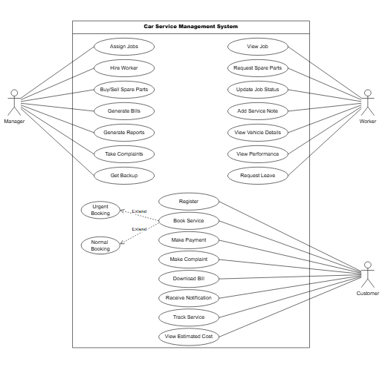
Figure 2.1-1 Use case diagram for car service management system

Activity diagram and Swimlane diagram

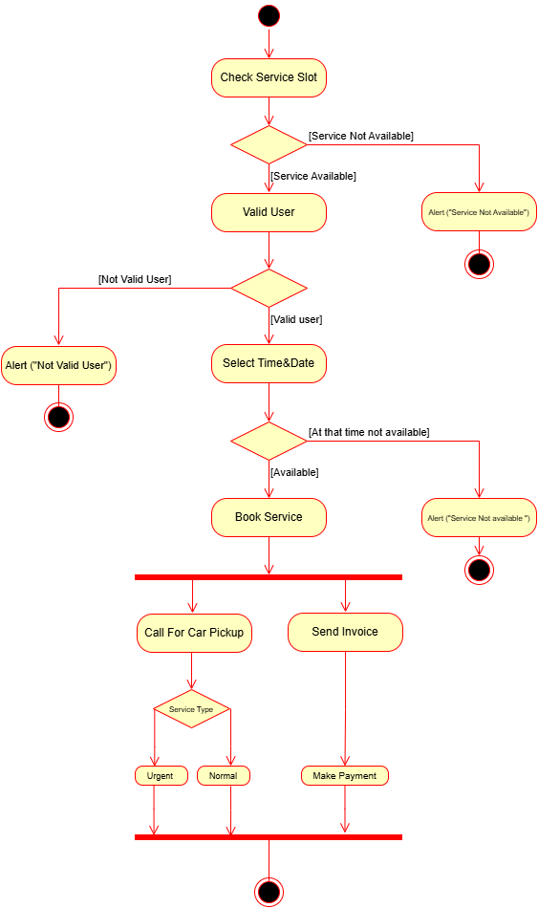
Figure 2.2-1 Activity diagram for service slot booking

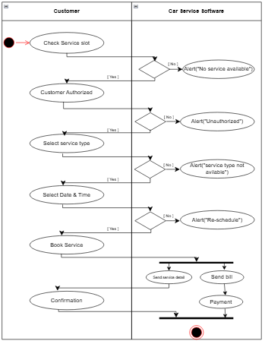
Figure 2.2-2 Swimlane diagram for car service management

Sequence diagram

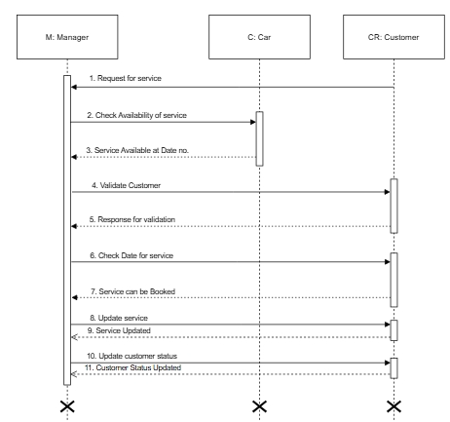
Figure 2.3-1 Sequence diagram for car Service management

State diagram

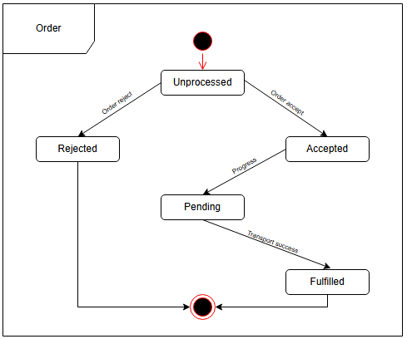

Figure 2.4-1 State diagram of Order

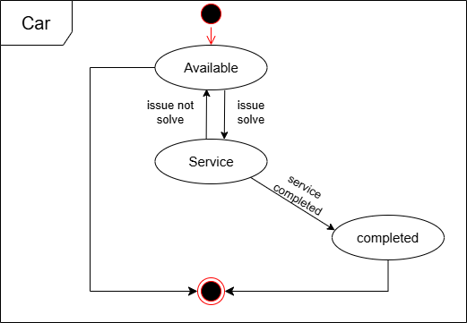
Figure 2.4-2 State diagram for car

Class diagram

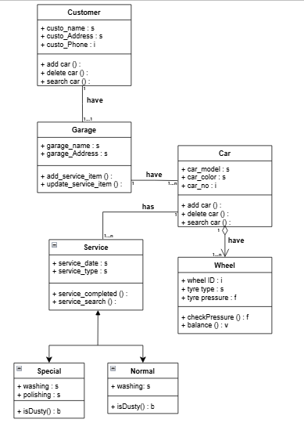

Figure 2.5-1 Class diagram for car service management system

Data flow diagram

Context diagram (level-0)
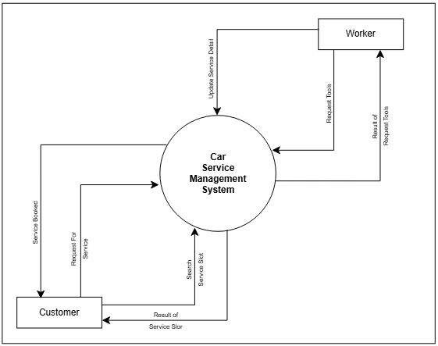
Figure 2.6-1 Context diagram for car service management system

DFD Level-1
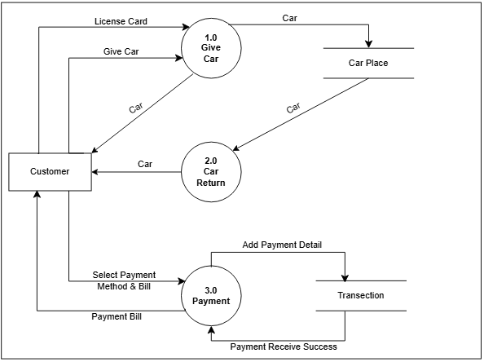
Figure 2.6-2 DFD level-1 for Car service management system

External interface requirement (Screens)

Screen-1: Registration Form

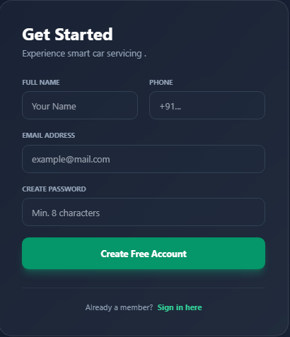

Figure 3.1-1 Screen-1: Registration Form

Purpose: This form will allow the target end-users to register in the system. To register , the following information will be encoded in the system.

Table 3.1-1 Screen element of Registration form
Sr. | Screen Element | Input Type | O/M | 1/N | Description
1 | FullName | Textbox | M | 1 | Username field should be editable and accept the Username.
2 | Phone | Textbox | M | 1 | Phone field has write user contact number
3 | Email | Textbox | M | 1 | Email field should be editable and accept the email with proper format.
4 | Password | Password | M | 1 | Password field should be editable and accept the password and display as star or dot.
5 | I already have a membership | Link | ------ | ------ | Link for navigate to login page for registered user.
6 | Create Free  Account | Button | ------ | ------ | That is a button for store the entered data into database.

Screen-2: Login Form

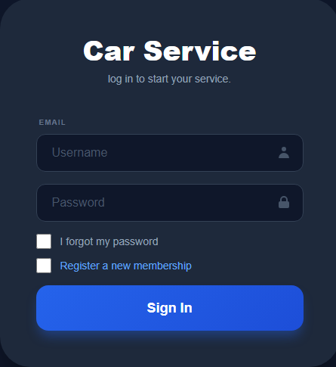

Figure 3.2-1 Screen-2: Login Form
Purpose: This form will be used by the system’s users to access records and features of the system. The users will input the correct combination of their username and password to be able to login to the system.

Table 3.2-1 Screen element of Login form
Sr. | Screen Element | Input Type | O/M | 1/N | Description
1 | Username | Textbox | M | 1 | Username field should be editable and accept the Username.
2 | Password | Password | M | 1 | Password field should be editable and accept the password and display as star or dot.
3 | Remember Me | Checkbox | M | 1 | Saving login credentials through remember me checkbox
4 | I forgot my password | Link | ------ | ------ | Link for navigate to Forgot password page for allows users to recover password.
5 | Register a new membership | Link | ------ | ------ | Link for navigate to membership registration.
6 | Sign in | Button | ------ | ------ | Login button navigates to another page even if valid login credentials.

Screen-3: Book Car Service

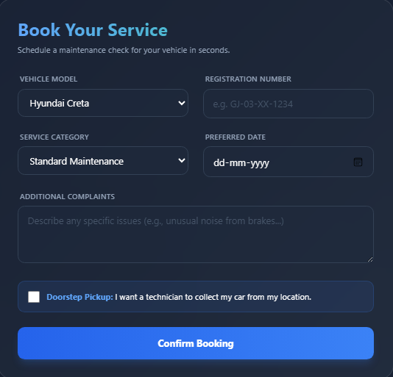

Figure 3.3-1 Screen-3: Book car service

Purpose: This module will allow the system customer to add details of car. The customer can book service .
of car and also describe any specific to do in service.

Table 3.3-1 Screen element of Add borrower book
Sr. | Screen Element | Input Type | O/M | 1/N | Description
1 | Vehicle Model | Dropdown | M | 1 | Vehicle Model shows which companies car is and what is manufacture year.
2 | Registration Number | Textbox | M | 1 | Registration number is assign number therefore anyone can find the owner.
3 | Service Category | Dropdown | M | 1 | Select type (Standard Maintenance, Deep Cleaning, etc..
4 | Preferred Date | Datepicker | M | 1 | User selects a future date for the service appointment.
5 | Additional Complaints | Textbox | M | 1 | Last Name field should be editable and accept only string as a borrower last name.
6 | Contact | Textbox | O | 1 | Accept strings describing specific vehicle issues..
7 | Doorstep Pickup | Checkbox | O | 1 | Boolean choice to request vehicle collection from home..
8 | Confirm Booking | Button | ----- | ----- | validates and stores the booking in the 'Appointments' table

Screen-4: Tracking Service Status

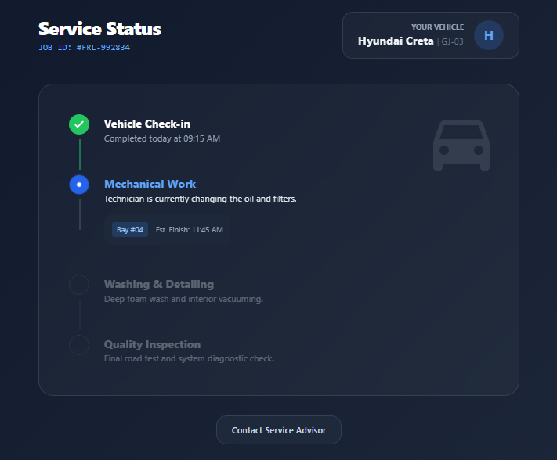

Figure 3.3-1 Screen-4: Tracking Service Status

Sr. | Screen Element | Input Type | O/M | 1/N | Description
1 | Job ID | Lable | ------ | 1 | Display unique auto-generated Service ID.
2 | Vehicle Info | Label | ------ | 1 | Display Model and Reg. No. fetched from the booking table..
3 | Progress Timeline | Graphic | M | N | Dynamic vertical list showing Completed vs. Active stages..
4 | Bay Info | Label | ----- | 1 | Displays the workshop bay number assigned to the car.
5 | Est. Finish Time | Label | ----- | 1 | Displays system-calculated completion time.
6 | Contact Advisor | Button | ----- | 1 | Triggers a call or chat action to the assigned service manager

Screen-4: Car Health Analysis

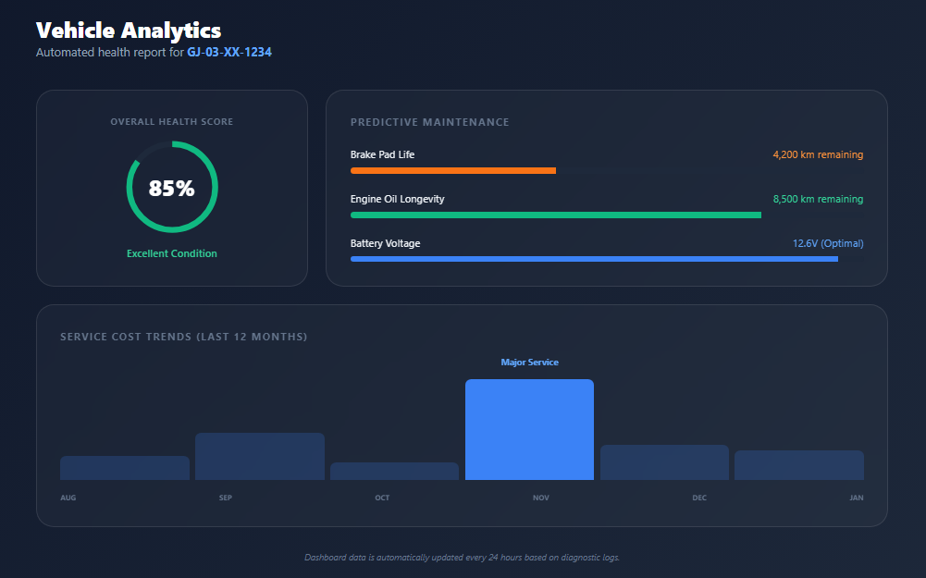

Figure 3.3-1 Screen-5:Car Health Analysis
Sr. | Screen Element | Input Type | O/M | 1/N | Description
1 | Overall Health Score | Chart | ----- | 1 | Circular percentage showing aggregate vehicle condition.
2 | Predictive Progress | Progress Bar | ----- | N | Visual bars for Brake Life, Oil Longevity, and Battery.
3 | Cost Trends | Bar Chart | ----- | 1 | Monthly cost comparison for the last 12 months..
4 | Health Status | Label | ----- | 1 | String indicator (e.g., "Excellent Condition") based on score.
5 | Data Timestamp | Label | ----- | 1 | Shows the last time diagnostic logs were synced

Database design

List of Tables
- Car
- Customer
- Garage
- Worker
- Garage owner

Table 4.1-1 Table: Car
Column | Data Type | Null | Keys & Constrains | Default Value & Description
Car_ID | Varchar(100) | NN | PK (Auto Increment)
Car_Name | Varchar(100) | NN
Manufacture_Year | Date | NN
Registration_No | int | NN
Fuel_Type | Varchar(50) | NN

Table 4.1-2 Table: Customer
Column | Data Type | Null | Keys & Constrains | Default Value & Description
Customer_Name | Varchar(100) | NN
Mobile_NO | Varchar(100) | NN
Address | Varchar(100) | NN
Age | Int | NN
Email | Varchar(100) | NN
Car_ID | Varchar(100) | NN | FK | Reference of car table
Customer_ID | int |  | PK

Table 4.1-3 Table: Garage
Column | Data Type | Null | Keys & Constrains | Default Value & Description
Vehicle_Count | Varchar(100) | NN
Address | Varchar(100) | NN
Worker_ID | Int | NN | FK | Reference of worker table
Garage_ID | int | NN | PK (Auto Increment)

Table 4.1-4 Table: Worker
Column | Data Type | Null | Keys & Constrains | Default Value & Description
Worker_ID | int | NN | PK (Auto Increment)
Worker_Name | varchar(100) | NN
Specialization | varchar(100) | NN
Experience | int | NN
Car_ID | int | NN | FK | Reference of car table

Table 4.1-4 Table: Service Booking

Column | Data Type | Null | Keys & Constrains | Default Value & Description
Service_ID | int | NN | PK (Auto Increment)
Booking_Date | varchar(100) | NN
Status | varchar(100) | NN
Custimer_ID | int | NN | FK | Reference of customer table
Car_ID | int | NN | FK | Reference of car table
Worker_ID | int | NN | FK | Reference of worker table

Stories and Scenario

Story-1: Add New Car in car service

Story # S1 | : | As a customer,  I want to add a new car in car service  So that everyone can easily find and borrow it.
Priority | : | High
Estimate | : | XL
Reason | : | The addition of a new car to the car service is crucial for ensuring that the car service’s collection is up-to-date and accessible to everyone.

Scenario# S1.1
Scenario# S1.1 | : | Adding a New Car with Valid Information
Prerequisite | : | Customer is logged in to the car service management system.
Acceptance Criteria | : | Given: The Car owner is logged in to the car service management page  When:  The car owner selects the "Add New Car" option and enters valid car details, including the car’s unique identification number, owner’s name, car make/model, license plate, insurance details, and other relevant information.  Then the system should successfully add the car to the service.

Scenario# S1.2
Scenario# S1.2 | : | Adding a New Car with Invalid Information.
Prerequisite | : | The Customer must be logged into the car service management system.
Acceptance Criteria | : | Given: The car owner is on the car service management page,  When: The car owner selects the "Add New Car" option and enters incomplete or incorrect car documentation (e.g., missing car number, invalid license plate, invalid owner name),  Then the system should display error messages indicating what information is incorrect or missing.

Scenario# S1.3
Scenario# S1.3 | : | Attempting to Add a Same car in service
Prerequisite | : | The customer is logged into the car service management system and the customer is on the car service management page
Acceptance Criteria | : | Given: The car information, including model, fuel, registration number, and other relevant details, is available and the same car is already in the car service.  When: User Clicks on “Add new car” button. Enter registration number with the same car detail mentioned in the field.  Then: Generate unique service id, barcode and spine label for various car service.

Story-2: Search for Car in Service
Story # S2 | : | As a Customer or member,  I want to search for car in the car service  So that I can easily find and rent a car available in the service.
Priority | : | High
Estimate | : | L
Reason | : | Enabling the search functionality for cars in the service ensures users can find the available cars quickly and conveniently, improving the user experience and overall service efficiency

Scenario# S2.1
Scenario# S1.1 | : | Searching for an Available Car in the Service
Prerequisite | : | The customer is logged in to the car service system.
Acceptance  Criteria | : | Given: The customer is on the car service homepage.  When: The customer navigates to the search bar or filter options. The car borrower enters a car's specific details (e.g., car number, model, or location). The customer selects the search button to start the search.  Then The system displays a list of available cars matching the search criteria. The customer is able to view detailed information about each car, including its availability, price, and other relevant details. The customer can select a car from the search results to proceed with booking or renting.

Scenario# S2.2
Scenario# S1.1 | : | Searching for a Car-by-Car Number
Prerequisite | : | The customer is logged in to the car service system.
Acceptance  Criteria | : | Given: The customer is on the car service homepage.  When: The customer enters the specific car number or unique identification code in the search bar. The customer clicks the "Search" button.  Then The system displays the car with the exact car number or ID entered by the borrower. The system shows the car’s availability, model details, and any other relevant information. The customer can proceed with renting or viewing more details about that specific car.

Story-3: Remove Car
Story # S3 | : | As a customer,  I want to remove my car from the car service  So that it is no longer available for borrowing.
Priority | : | High
Estimate | : | M
Reason | : | Removing a car from the service is important when the car is no longer available for use, such as when it’s sold, damaged, or no longer in service. This helps keep the car service up-to-date and prevents users from attempting to borrow unavailable cars.

Scenario# S3.1
Scenario# S1.1 | : | Removing a Car with Valid Documentation
Prerequisite | : | The car owner must be logged in to the car service management system.  The car to be removed must already be listed in the car service.
Acceptance  Criteria | : | Given: the car owner is on the car service management page,  When: the car owner selects the "Remove Car" option for a specific car they own, and the car owner confirms the removal action  Then the system should successfully remove the car from the service, and the car owner will receive a confirmation message that the car has been removed from the service.

Scenario# S3.2
Scenario# S1.2 | : | Removing a Car That Is Not Owned by the User
Prerequisite | : | The car owner must be logged in to the car service management system. The car to be removed is not owned by the logged-in car owner.
Acceptance  Criteria | : | Given: the car owner is on the car service management page,  When the car owner tries to select the "Remove Car" option for a car that is not registered under their ownership,  Then the system should display an error message stating "You do not have permission to remove this car," and the car will not be removed from the service.

Story-4: Add extra service in car service

Story # S3 | : | As customer,  I want to add extra service in car service  So that I can give detail in description area .
Priority | : | Medium
Estimate | : | M
Reason | : | I want some special treatment in service for car and with some special brand items .

Story-5: Generate a report on car service feedback and its flexibility

Story # S3 | : | As manager,  I want to generate reports on car services feedback and its service  So that I can give information about those services.
Priority | : | Medium
Estimate | : | L
Reason | : | Reporting functionality helps manager to track the service of car and make data-driven decisions to improve services and equipments.

Scenario# S1.1
Scenario# S1.1 | : | Generating report on good feedback
Prerequisite | : | manager is logged in to the car service management system.
Acceptance Criteria | : | Given: The manager is navigated to the car service management page. Analyses the reviews of car services.  When:  The manager selects the "Good Reviews" option  And The manager navigates to the review page of that services.  Then: manager generates report on services that have good review.

Scenario# S1.2
Scenario# S1.2 | : | Generating report on bad feedback
Prerequisite | : | Manager is logged in to the car service management system.
Acceptance Criteria | : | Given: The manager is navigated to the Car service management page. Analyses the reviews of products.  When:  The manager selects the "Bad Reviews" option  And The manager navigates to the review page of that services.  Then: manager generates report on services that have bad review and improves quality of those services.

Scenario# S1.3
Scenario# S1.2 | : | Filling report on feedback
Prerequisite | : | Customer is logged in to the car service management system.
Acceptance Criteria | : | Given: The customer is navigated to the Car service management page. give the reviews of services.  When:  The customer selects the "Bad Reviews" or "Bad Reviews" option  And The customer navigates to the review page of that services.  Then: customer fill report on services that have review and improves quality of those services.

Test cases

Project Name: | EMI Calculator | Test Designed by: | P. U. Jadeja
Module Name: | Login | Test Designed date: | 01-10-2023
Release Version: | 1.0 | Test Executed by: | R. B. Gondaliya
 |  | Test Execution date: | 15-01-2023

Pre-condition: Web application should be accessible
Test Case ID | Test Title | Test Type | Description | Test Case ID
TC_001 | Login to web application with valid credential | Functional | Login to Library management system web application through valid credential | TC_001
TC_002 | Login to web application with invalid credential | Functional | Login to Library management system web application through invalid credential | TC_002
TC_003 | Varify login page elements | GUI | varify that all elements are availabe on login page | TC_003

Test Case Title | Login to web application with valid credential
Test Type | Functional
Test Priority | High
Pre-condition | Web application should be accessible

Test Step | Test Case Description | Expected Result | Actual Result | Status | Comment | Data | BUG ID
1 | Access Web application URL | The site launched properly | Site launched successfully | Pass |  | https://accounts.google.com/ServiceLogin
2 | Enter valid Username in username field | Username field should be editable and accept the Username | Username input accepted | Pass |  | Username:  Rbgondaliya@gmail.com
3 | Enter valid Password in Password field | Password field should be editable and accept the password and display as star or dot | Password input displayed in dot and accepted | pass |  | Password:  rbgondaliya
4 | Enter valid captcha code in captch field | Captch field should editable and accept captcha and captcha is case sensitive | Captcha input accepted | Pass | Step required when human action validation perform | get captcha from image which is near by captcha field
5 | Click on login button | User should login into site and navigated to dashboard | User navigated to dashboard and username should br display in top of the right side. | pass

Test Case Title | Login to web application with invalid credential
Test Type | Functional
Test Priority | Medium
Pre-condition | Web application should be accessible

Test Step | Test Case Description | Expected Result | Actual Result | Status | Comment | Data | Bug ID
1 | Verify that User is not able to Login with invalid Username and invalid Password | Should be display an error message enter wrong username or password | Display an error of wrong username and password | Pass
2 | Verify that User is not able to Login with Valid Username and invalid Password | Should be display an error message enter wrong password | Display an error of wrong password | Pass
3 | Verify that User is not able to Login with invalid Username and Valid Password | Should be display an error message User not found | Display an error Username not found | Pass
4 | Verify that User is not able to Login with blank Username or Password | Set required field validation message for Username and Password | Display an error of wrong username and password | Fail | Not performa a validation function fix it |  | Bug_002

Test Case Title | Varify login page elements
Test Type | GUI
Test Priority | Medium
Pre-condition | Web application should be accessible

Test Step | Test Case Description | Expected Result | Actual Result | Status | Comment | Data | Bug ID
1 | Launch application with the given url | The site launched properly | Site launched successfully | Pass |  | https://accounts.google.com/ServiceLogin
2 | Verify that the login screen contains elements such as Username, Password, Sign in button, Remember password check box, Forgot password link, and Create an account link. | All listed control displayed properly on the page | Login page loaded successfully | Pass
3 | Verify that cursor is focused on “Username” text box on the page load | Cursor is focused in Username textbox | Cursor focus in Username textbox | Pass
4 | Verify that tab functionality is working properly or not | When tab pressed cursor move in next control | Cursor moving in next control | Pass
5 | Verify that all the fields such as Username, Password has a valid placeholder | All text fields have proper placeholder | All text fields have proper placeholder | Pass
6 | Verify that the labels float upward when the text field is in focus or filled (In case of floating label) | When field is focused or filled, label display on top of the filled | When field is focus or filled, label display on top of the filled | Pass | step required when fields with floating label
7 | verify that forgot password link working properly | when click on forgot password load forgot passworg page | forgot password link not working | Fail

References

- http://www.w3schools.com/html/html_intro.asp
- https://www.w3schools.com/php/default.asp
- https://www.javatpoint.com/uml

